# Y8 Database Project File

Work your way through the questions and tasks in this file using the [computer_science_database](https://www.hockerillct.com/16/CT/year8/81%20Database/computer_science_database.accdb) as instructed. You will need to open this document in the full desktop version of word.

## Introduction

**Fill in the blanks using words from the drop down lists:**

**What is a database?** youtube link (Miss P):[**https://www.youtube.com/watch?v=cA4c0yda8Hs**](https://www.youtube.com/watch?v=cA4c0yda8Hs)

A database is an Choose an item. collection of data. Organising data so it means something creates Choose an item.. In a database the data is organised into Choose an item. Each table is organised into Choose an item. Into which the different types of information are put.

Example: A List of Contacts is a database.

|  |  |  |  |  |  |  |  |
| --- | --- | --- | --- | --- | --- | --- | --- |
| Fields: | First name | Surname | Mobile number | Home number | Work number | Address | e-mail |
| Example  Data: | Lisa | Simpson | 074867256878 | 01279 977907 | - | Springfield | lisa@thesimspsons |

The information for the entries in the table are called Choose an item. and these are made up of the **data items** entered into each field for that record. Database Choose an item. allow the data to be filtered so the user can see the information they want more easily. Database Choose an item. allows the user to access and update the data in the database.

## Part one – Using a database

**Carry out the following tasks using your copy of the Computer Science Database. Open the database and click on Enable Content (there may be confirmation screens to agree to open the document as a trusted document first). Try to answer each question.**

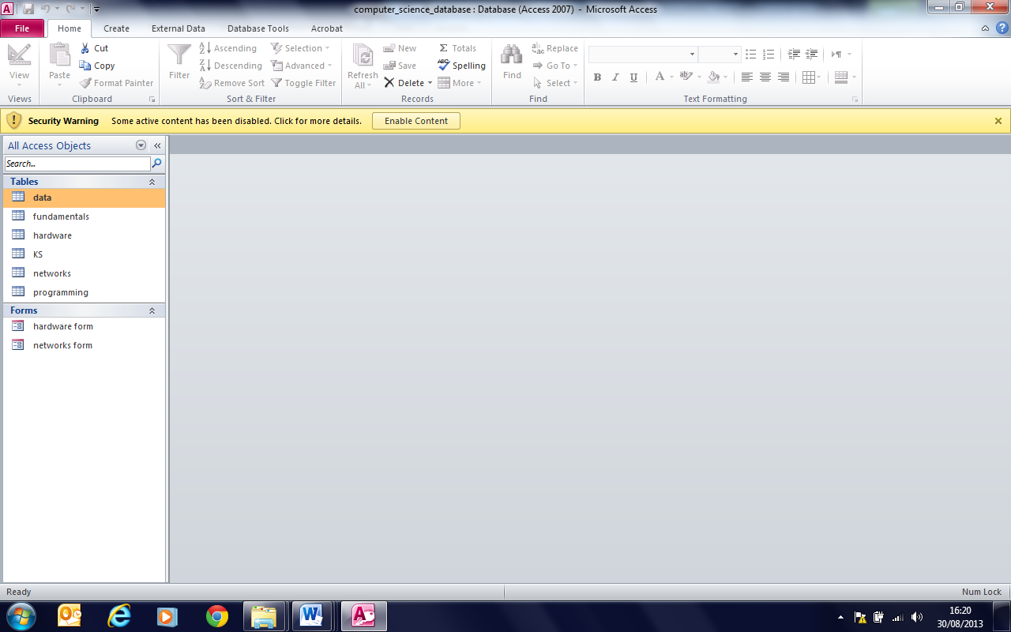

1. **Viewing records and fields of a table**
   1. Open the **data** table by double clicking “data” from the list of tables. How many records are there in the data table? Answer: Choose an item.
   2. One of the data items in the table is a byte, another is a kilobyte.
      1. How many bits are there in a byte? Answer: Choose an item.
      2. How many bytes are there in a kilobyte? Answer: Choose an item.
   3. **Data item** is that name of the first field in this table what is the name of the fifth field? Answer:Choose an item.
   4. Use the **web link** on the kilobyte record to take you to a site discussing kilobytes, megabytes etc. What is the alternative answer to b(ii)? Answer:Choose an item.
2. **Viewing field properties**
   1. 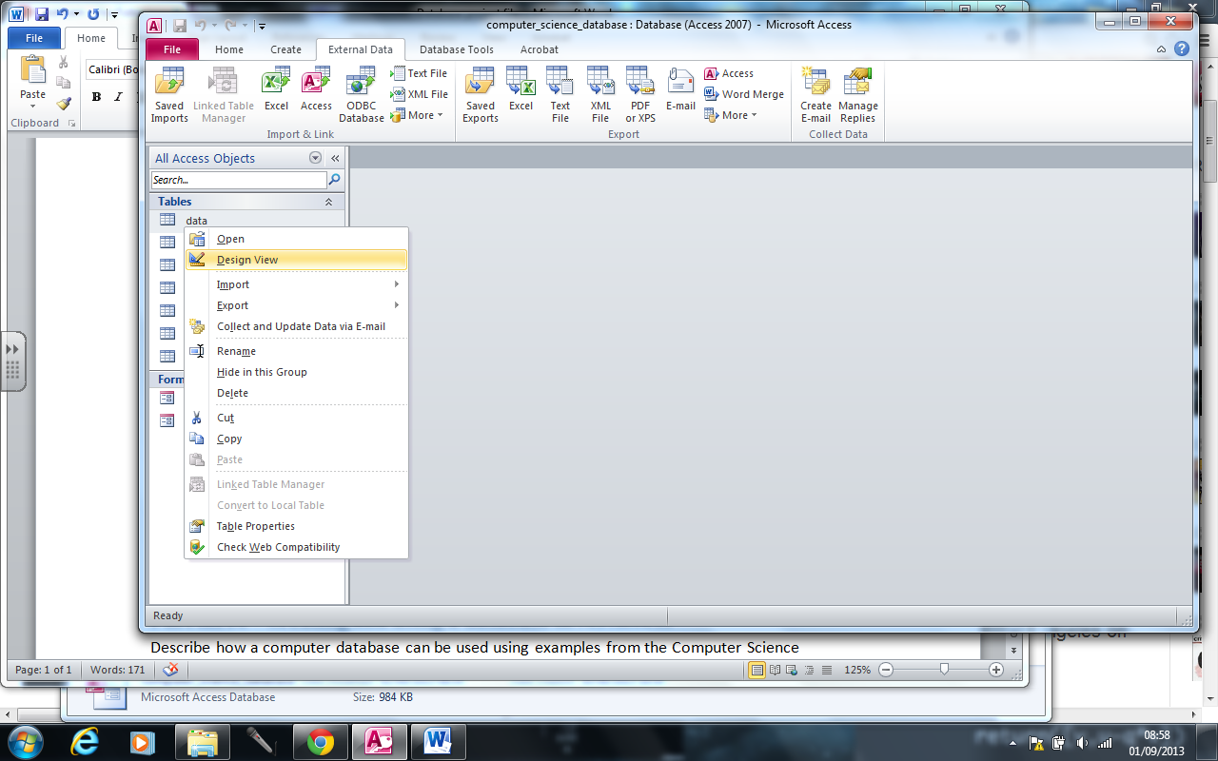Open the **data** table in design view. This can be done by a right click on “data” from the list of tables and selecting design view. Here you can see the field names **and** data types. How many of the fields have number as their data type? Answer:Choose an item.
   2. Select the **data_item** field. The properties panel underneath shows the properties of the data_item field. What is the field size of the “data item” field? Answer: Choose an item.
   3. The field size of the description field has not been changed from the default value which means the value that is put in automatically by the database software. Click on the **description** field. What is the default field size? Answer: Choose an item.
   4. Open the **fundamentals** table and read through the entries. Answer these questions by using the information from the **description** field of the table (you can copy and paste when appropriate):
      1. What is software?
      2. What is programming?
      3. Computers are often described as devices that perform Input – Process – Output operations. What is inputted, processed and outputted?
      4. What is a peripheral device?
      5. What is memory?
      6. What is the difference between primary and secondary storage?
      7. What is “The communication mechanism between one object and another”?
3. **Lookup lists, Filters, Adding records**
   1. 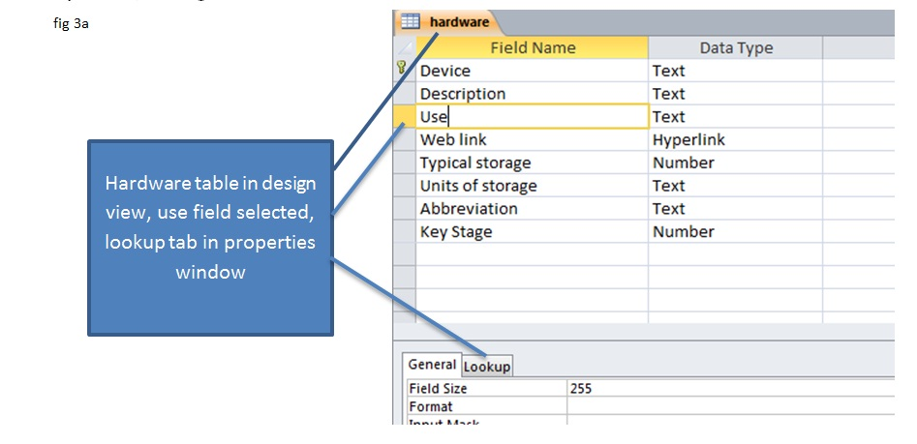Open the **hardware** table in design view (see fig 3a below). Select the **use** field as above. Click on the lookup tab. What are the uses that are suggested in the row source? Answer: Choose an item.
   2. 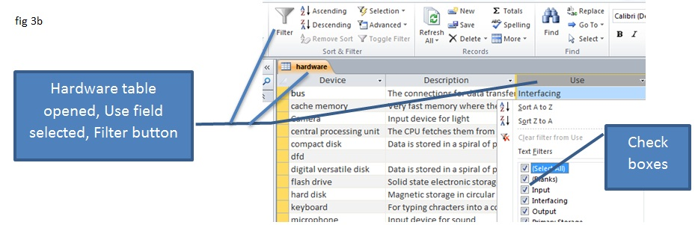You are goiung to use a filter to only display output devices in the **hardware** table. Open the table in datasheet view (open it normally). Select the **use** field then select Filter to get a screen like the one shown here (fig 3b). In the check boxes unselect “select all” and select “Output” then OK. What are the three output devices displayed? Answer:Choose an item.
   3. There is at least one output device missing. Enter a new record on the fourth row for the output device a computer uses to output sound. Use this link if you are stuck: <http://library.thinkquest.org/08aug/01795/Website/output_devices.html> insert a screen clipping of the four output devices now in your filtered list below:
4. **Sorting**

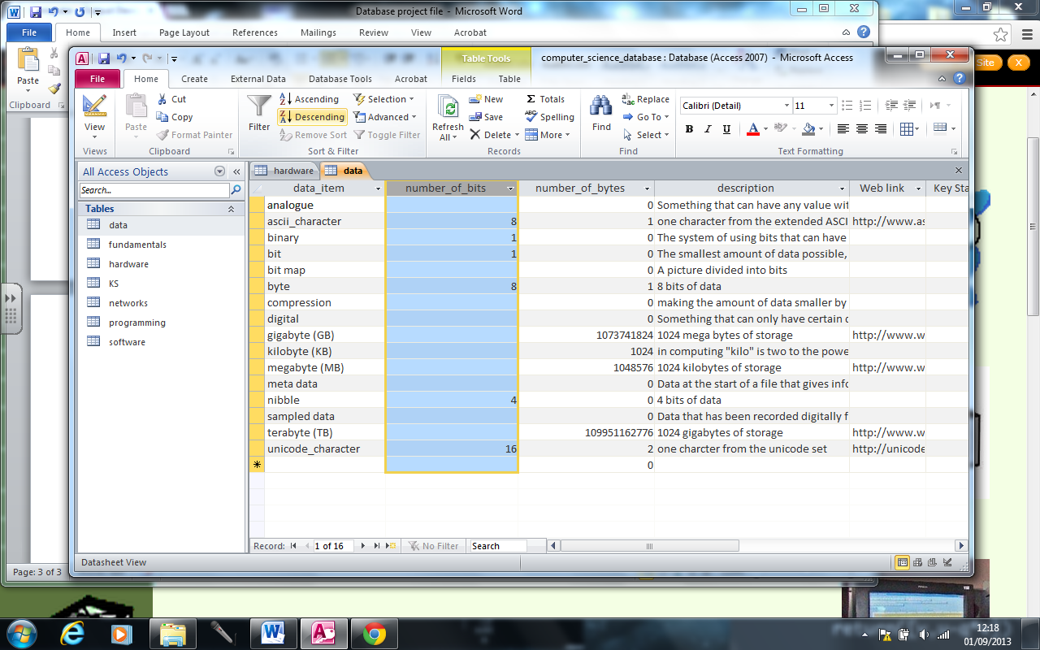Open the **data** table again this time you are going to order it first by number of bits descending (select the **number_of_bits** field then click the Descending button and then by number of bytes Descending. The resulting list should be largest to smallest amounts of data. Select the **data item, number of bits and number of bytes fields for all the records that have numbers in these columns**. Paste the contents of table below:

1. **Forms.**  Opening a table normally opens it in datasheet view where all the records are displayed at once. Forms can be created to view the data one record at a time. This prevents mistakes being made and is useful if you are showing information to a customer because other peoples information will not be displayed alongside it
   1. Which tables have had a forms created for them? Answer:Choose an item.
   2. Open the **programming** form and find out what a while loop does. Paste the action field contents as the answer to this task.

A while loop…….

* 1. Open the **software** form and find out what an operating system does.

An operating system….

* 1. Explain the advantage of creating a form

A form is sometimes better than opening a table in datasheet view because……

## Part two – Creating a table

The table on databases is missing from the Computer Science Database. You are going to

* create the databases table,
* create a form for adding the first few records
* 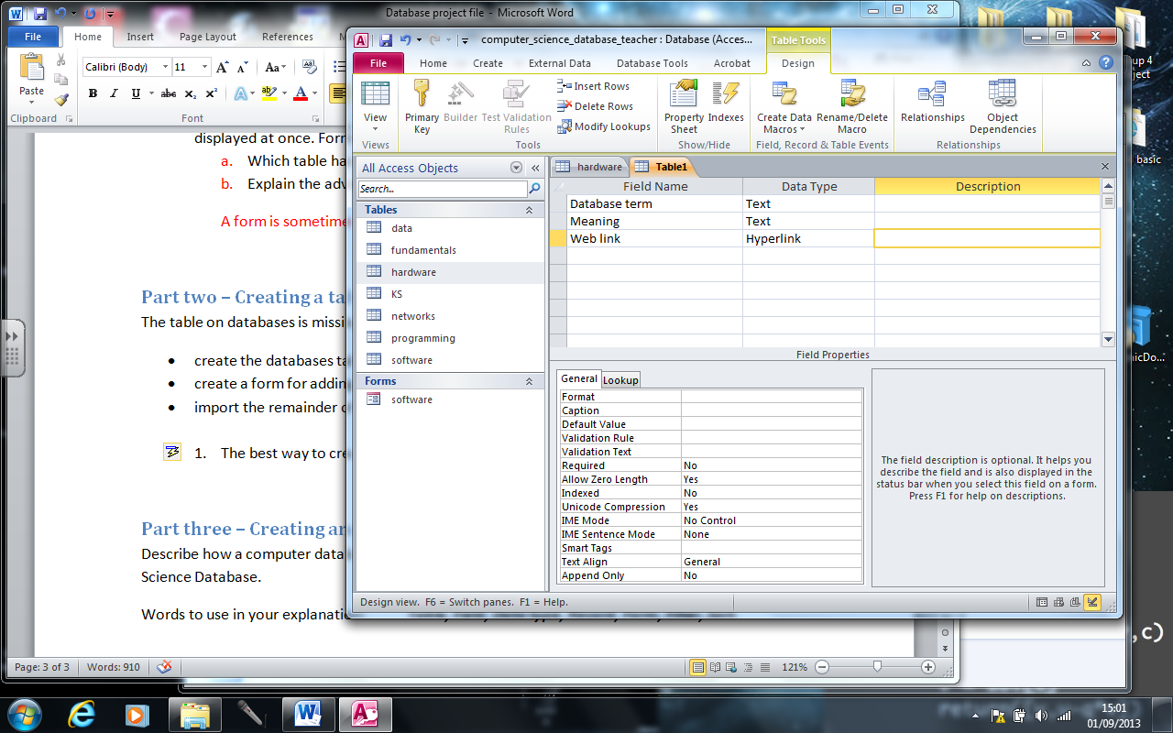import the remainder of the records from the database_terms file

1. Create the table using table design. Select Create and Table Design. Enter the field name and data types as shown on the right.
2. When you have done this close the table choose yes for saving it and call the new table database. Only a small amount of data is going into the table so a primary key is not necessary.
3. If you want select the database table then create form and the software will create a form for you. Close it and save it.
4. Enter the first two records into your table by using the form or opening the table.

|  |  |  |
| --- | --- | --- |
| Database | A structured collection of information | http://en.wikipedia.org/wiki/Database |
| Table | A set of similar data in a database | http://searchsoa.techtarget.com/definition/table |

It is a bit boring to enter data by hand. You have a pre-made text file with the rest of the data for the table. Close the table or form and then right click the database table selecting import and then text file. On the following screen you need to make changes: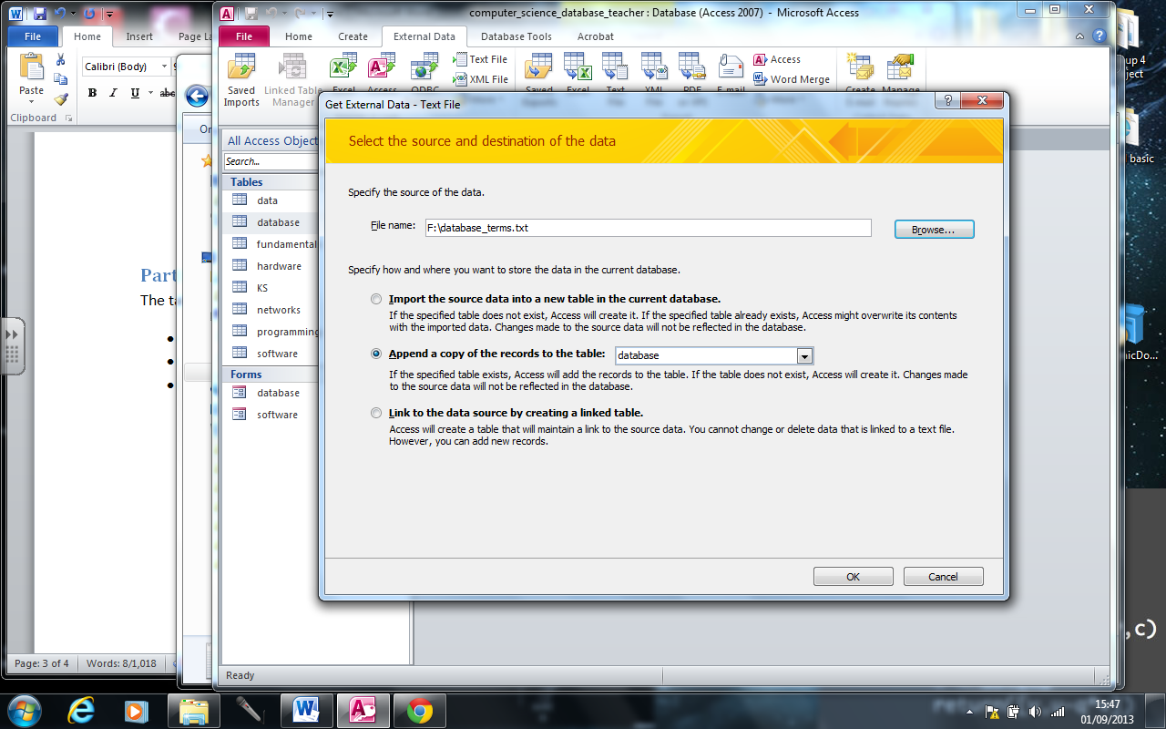

Browse to your copy of database_terms.txt

Choose the Append option and make sure it is the database table that is being appended to

On the screen that follow do not change anything, have a look at them if you want but just click Next or OK or Finish. If there are errors try and work out what has gone wrong.